🡪we can launch openstack cluster on the top of aws also.

🡪There is one thing you have to know.

🡪In OpenStack we have to launch vm on the top of vm, so we require HVM support for the base VM.

🡪Here we are launching on the top of ec2, so instance should be HVM.

🡪 give atleast 6 GB ram, 2 CPUS, 40 GB HD (12, 4 CPU,50 recommended).

🡪we use centos-7 with HVM

🡪Provided 16GB ram, 4CPU, 80 Gb HD.

🡪t2.xlarge, launched in 1-a, 80 GB EBS storage, tag=openstack, allowed all traffic in SG for this practice only (not recommended), launch instance.

🡪We copy the openstack software in extra EBS (30Gib) and attach to the instance.

🡪use putty for connecticity.

🡪This centos image is created by someone else.

🡪you have to use [centos@192.234.234.324](mailto:centos@192.234.234.324) for connectivity.

🡪use auth key.

🡪Now mount that EBS storage  
 🡪mkdir /software

🡪mount /dev/xvdf /software

🡪create yum repo for this software.

🡪yum install openstack-packstack

🡪yum install vim

🡪packstack --gen-answer-file=openstack.txt

🡪packstack --answer-file=openstack.txt

🡪Here NetworkManager service is not available. So, we are not going for disable part for this.

🡪Now if you want to use horizon by default, it open apache home page.

🡪You have to do one configuration for this.

🡪vim /etc/httpd/conf.d/15-horizon_vhost.conf

🡪add below things

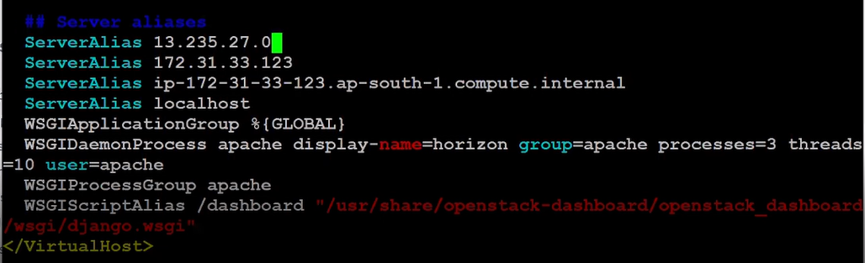

🡪add public IP (above).

🡪systemctl restart httpd

🡪yum install wget -y

🡪wget <url for image>

🡪glance image-create --file <image name> --disk-format qcow2 --container-format bare --name fed32

🡪it will upload your image.

🡪nova boot --nic net-name=private --flavor m1.small --image fed32 os1

🡪launch vm for you.

Magnum

🡪If you want same as EKS service inside openStack, you have to use Magnum.  
🡪In aws we have cloud formation or automation here we use Heat.

🡪we are using RHOSP version 13 for using openstack.  
🡪This will not come with magnum service inbuild.  
🡪They internally using queens release of openstack.

🡪For using magnum services, we using queens release directly in top of aws.

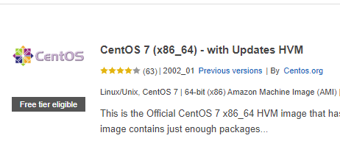



Add 100 gb storage.

Yum install centos-release-openstack-queens.noarch  
🡪It will create yum for you.  
🡪yum install openstack-packstatck vim -y  
🡪setencforce 0  
🡪packstack --gen-answer-file=a.txt  
🡪vim a.tx  
 🡪enable magnum and heat.  
🡪make IP permanent.  
🡪packstack --answer-file=a.txt

🡪Now OpeStack created.  
🡪You have to update the public IP here.  
🡪Go to vim /etc/httpd/conf.d/15-horizon_vhost.conf  
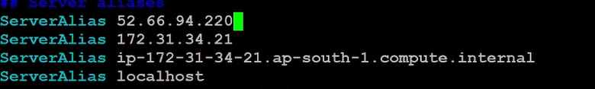  
🡪systemctl restart httpd

🡪we have some special OS only mint for COE.  
🡪It is also known as thin os.  
🡪Download that image from internet.  
🡪Here for magnum we have to create template.  
🡪For this we need inside image, we have to set property.  
🡪template only look for this distro, this distro represent image is thin.  
🡪openstack image set –property os_distro=fedora-atomic <ID>  
 🡪openstack only support some (3-4) of the distro.

🡪openstack coe cluster template create mycluster <options>.  
 🡪It will create template for you.

🡪from this template create cluster for you using GUI.